# Creative Piece Concept

## Bob the fish (subject to change)

### Story

I have an idea for an application to that I feel fits into the theme of ”As long as we have each other, we will never run out of problems”.

The application will tell the story of two fish living together in a fish tank. You have control of one fish called Bob and need to stay alive for as long as you can while challenges arise throughout your day. The entire application takes place in one fish tank so minimal assets are required. The focus will be on your interactions with the fish your control.

During the day Steve will be a burden and at night an ally. I wanted to tie the application into the theme “As long as we have each other, we will never run out of problems” by showing how two fish live in a tank. I found the inspiration for my design after staring at my fish tank I have at home. I have 3 fish in the tank and they always fight during the day but huddle up at night. As much as they have one another and need each other to survive, they will always have problems.

### Design and Technology

#### Engine and Technology

I will use the Unreal 4.22 engine to design the application and utilize blueprint and C++ for development. I choose Android (26 – Oreo and up) as my platform of choice for this project as it supports Vulkan and Google ARcore which are two core plugins/tools I plan to use. My compiler will be Visual Studio 2018 and all code will be compiled from source code of the Unreal Engine as it will be required during plugin integration.

#### Controls

I will be building interactions around mobile touch controls. The user will only need to touch or pinch the screen to navigate around the application. There are already default mobile touch/stick controllers found in Unreal Engine that will help speed up prototype and be used as a base to build on moving forward.

#### AR

I want to integrate AR into the application and provide a feature where the user can place the fish tank on any surface in a real-world location and then interact with your fish. I will implement this feature using Google ARcore technology that comes as a plugin with the Unreal Engine.

#### Environment

A day/night cycle will be implemented that will be two minutes per day and feature their own unique challenges that the user will need to overcome to survive. This will be interesting to try and implement on AR as light adapts to the light in the room. This will need an AR day/night simulation around the tank in AR to change the look of the environment during dawn to night and dusk till day.

Lighting will be dynamic in the application. This will cost a bit more resources on mobile and will need to be monitored.

#### UI/GUI

The UI will feature a 2D main landing page that contains buttons for Start Game, AR, Exit Application and High Score. A pause menu will be available while the experience is running that can restart, place AR tank or return to main menu. The GUI will display stress, health, days and time that all hold a value. A menu button will be located on the top left that will bring up the pause menu. The text inside the GUI and UI will be in Roboto Font.

All text should not be images as it makes the process of translations harder at a later stage of development. Using the Unreal Engine translation feature, text can be translated into 21 languages very quickly.

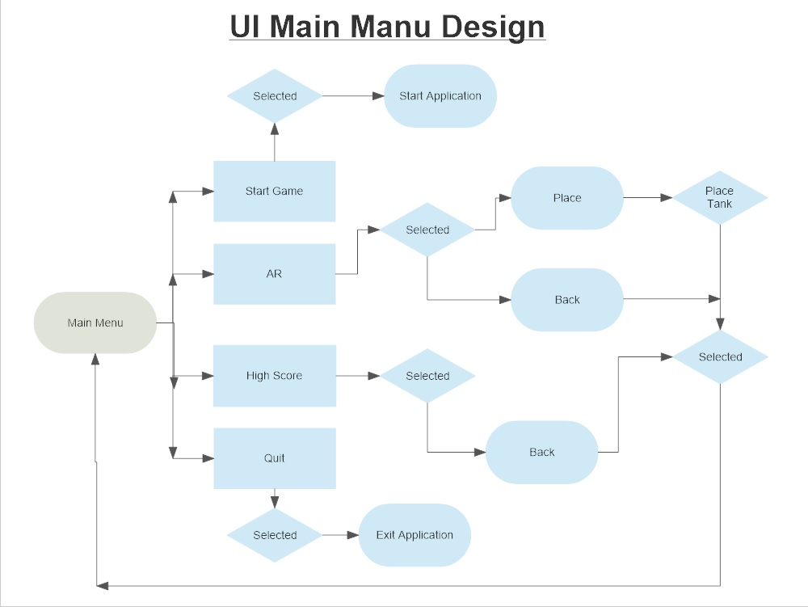

#### Roadmap

Later in development I would look at implement a “Create a tank” feature where the user can place objects inside the tank to build their own. The User will be able to store the designs locally when implemented and load from library where items and designs are located.

### Requirements to run application:

#### PLATFORM

OS: Android 8.0 (Oreo) and up.

Chipset: Qualcomm MSM8996 Snapdragon 820 (14 nm) equivalent or better.

CPU Quad-core (2x2.15 GHz Kryo & 2x1.6 GHz Kryo) equivalent or better.

Octa-core (4x2.3 GHz Mongoose & 4x1.6 GHz Cortex-A53) equivalent or better.

GPU Adreno 530 - G9350 equivalent or better

Mali-T880 MP12 - G935FD, G935F, G935W8 equivalent or better

#### MAIN CAMERA

Single: 12 MP, f/1.7, 26mm (wide), 1/2.55", 1.4µm, dual pixel PDAF, OIS

Features: LED flash, auto-HDR, panorama

Video: 2160p@30fps, 1080p@60fps, 720p@240fps, HDR, dual-video rec.

Ram: 4 GB equivalent or better

### Assets

Assets needed are created using a combination of Blender and GIMP. Both Blender and gimp are free to use open source and will cover all my animation, modelling and texturing needs for my assets. I will be using only a few assets at first as the focus will be on interaction and AR rather then content at the start of development.

Animation will be physics driven for some objects so only basic rigging and bone structures will be required. The two fish will need to be rigged and skinned for animation and a bone structure of 15 bones will be used. Mobile has a limit of 75 on Unreal Engine 4 deployment, but this should not be a issue as assets won’t benefit from a complex one structure for animation.

Textures will be 2k resolution and all materials are developed in Unreal Engine using the material editor and blueprinting.

#### Basic Asset List:

UI/GUI - Buttons, Borders, Banner

3D Models - 1x Fish, Tank, 2x Fish, 3x Aquatic Plants, 4x rocks, 1x Boat, 1x Pump, 1x Heater, 2x Flakes

### Testing

Testing will be done using Android Studio to launch virtual devices and simulate the camera for AR. Unreal editor has its own quick on the fly testing by running the application inside the editor. I will also be testing my application on a Samsung Galaxy S7 edge as my external testing device. The debugging will be done using Android Studio that can provide feedback from my mobile device.

Basic testing will be done while implementing features and designs and playtesting will occur once a week.